SPEECH TO 3D MODEL GENERATION

Meet Jain
Department of Computer Engineerring
Smt. Kashibai Navale College of Engineerring
Pune 411041,India
Email id:- jainmeet053@gmail.com
Prashika Nikose
Department of Computer Engineerring
Smt. Kashibai Navale College of Engineerring
Pune 411041,India
Email id:- prashikanikose@gmail.com
Aditi Karanjkar
Department of Computer Engineerring
Smt. Kashibai Navale College of Engineerring
Pune 411041,India
Email id:- aditikaranjkar225@gmail.com
Mayur Dalvi
Department of Computer Engineerring
Smt. Kashibai Navale College of Engineerring
Pune 411041,India
Email id:- mayurdalvi.5@gmail.com

Abstract— The ability to make a visible interpretation of the planet from the tongue is pivotal to human communication. Similarly, from a computational perspective, mapping descriptions of scenes to 3D geometric representations are useful in many areas such as robotics, interior design, and even education. Text to 3D scene generation is a task that addresses this problem space. A user provides natural language as an input and an output is a plausible 3D scene interpretation. This is a challenging domain connecting NLP and computer graphics. The few existing systems for generating 3D scenes from the text are restricted in scope and robustness. The key challenge, and focus of this dissertation, is in incorporating prior knowledge which is vital for successfully generating 3D scenes from highly under-specified natural scene descriptions. Earlier systems didn't leverage such priors, requiring explicit and verbose language. This dissertation formalizes and decomposes the problem of text to 3D scene generation, and describes the implementation of a new text-to-scene framework that enables incorporation of priors learned from data. The project proposes viewing the problem as extracting a set of explicit constraints from input descriptions, combining them with learned common-sense priors for inferring implicit constraints, and then selecting objects and positioning them to meet the constraints and generate plausible scenes.
Keywords—component, formatting, style, styling, insert (key words)

Introduction
The main characteristic of the audio to 3D model is to get a model which interacts with the world using 3d scene representation when the input is given is in audio. This 3D scene captures the dynamics and placement of the scene during the creation, offering to the user the possibility to change the point of view during the exhibition, beyond supplying the three-dimensional model of visualized objects. This application will help one visualize his/her imagination with 3D model representation. Also, we present a metric for automatically comparing generated scene templates to scenes, and that we show that it correlates strongly with human judgments. Automatic construction of three-dimensional photo-realistic models of a scene is vital in applications like interactive visualization of environment or objects that are remotely located. One could provide a modification of a true scene for computer game tasks. The system will be an asset in many cases, providing interesting and surprising interpretations, and when users want to control a depiction more precisely, they can adjust their language to better specify the exact meaning and graphical constraints they envision. Many creative industries use 3D scenes. Robotics applications need to understand commands referring to real-world environments, and the ability to visualize scenarios given high-level descriptions is of great practical use in educational tools. Other applications of 3D video are it are often utilized in Archeology, Oceanography, Historic and Cultural Sites, Arts, Education, and Entertainment.

Framework Description
The framework is divided into many steps including text recognition, natural language processing model, Trained model to identify objects from input, Data analysis to search and select appropriate objects , To apply spatial knowledge identified from the dependencies and placement of the objects accordingly. Model to identify objects used here increases the accuracy to select the appropriate object required by the user for the 3d scene. The conversion of audio to text is precise and fast. The proposed algorithm is mentioned in the form of steps below :-
- Take input from user(audio/text)
- If audio convert into text
- Pass input text for tokenization
- Pass tokens for object identification and save identified objects as array
- Check for object in object dataset
- Check dependency and spatial relationship between objects
- Pass the objects and dependency to output template.
- Display 3D representation.
- Ask user to login if yes then save the scene else go to step 1.
- Exit

System Implementation plan

Audio to Text Conversion
Voice search has evolved over the years. Google has already indicated that voice is fastest growing sort of search. As more gadgets are reliant on voice, website owners are waking up to the importance of this type of search, audio search has become an important part of Search engine optimization. Some of the trendsetters in voice search include Siri, Google Assistant, Alexa and Cortana which has audio search as one of the most important and used functions. The process of converting audio to text is the primary step in audio to 3D scene generation. Conversion of audio to text is done with the help of speech Recognition. Speech Recognition is also known as speech-to-text.

POS Tagging and Tokenization
POS tagging also called as Parts of Speech tagging is a step in Natural language processing. It is a branch of AI that deals with the interaction between computers and human using tongue . The NLP process is further divided into 6 steps which includes Tokenization, Stemming, Lemmatization, POS (Parts of Speech) Tagging, Name Entity Recognition and Chunking. Tokenization could be a way of separating a chunk of text into smaller units called tokens. Tokens can be referred as words, characters or sub-words. After Tokenization next step is stemming which is also a part of queries and Internet search engines. It is step by step process of reducing a word to its word stem that affixes to suffixes and prefixes or to the roots of words mentioned as Lemma. But sometimes stemming leads to meaningless words by removing letters from a meaningful word. In order to avoid this error, Lemmatization comes into consideration. It usually refers to doing things properly with the utilization of a vocabulary and morphological analysis of words, normally reaching to remove inflectional endings only and to return the base or dictionary form of a word called as Lemma. This above processes helps the next step that is POS tagging to identify the parts of speech of word and tag it accordingly based on its context and definition. The tags include ‘n’ for noun, ‘v’ for verb, ‘a’ for adjective, etc. Sometimes, the input text include name of person, name of place, etc. In order to identify in such conditions Name Entity recognition is used. Named entity recognition (NER), also referred to as entity chunking/extraction, is a popular technique utilized in information extraction to spot and segment the named entities and classify or categorize them under various predefined classes. After all the above processing like tokenizing, stemming, tagging and identifying finally comes the last process that is chunking. It is a process of extracting phrases from unstructured text, which means analyzing a sentence to identify the constituents (Noun Groups, Verbs, verb groups, etc.).

NLP phases
NLP is divided into four phases. To draw relation between the words in the input text and to identify objects to create for 3D representation this phase plays an important role. Natural language comes with lots of ambiguities in it. In order to tackle with such ambiguities and to remove them NLP consist of such phases.
- Morphological Processing
- Syntax Analysis
- Semantic Analysis
- Pragmatic Analysis
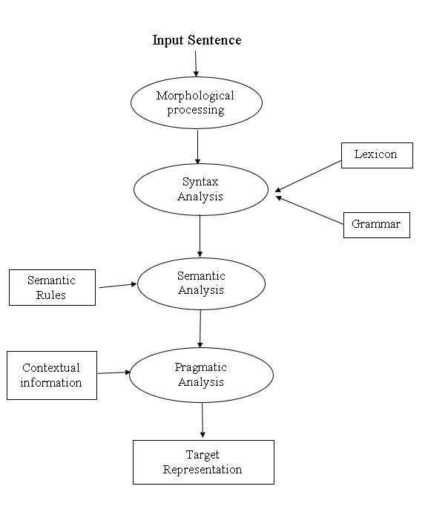
Figure 3.1 NLP PHASES

‘Stop words’ Identification
These are English words which does not add much meaning to a sentence. They can be directly ignored without sacrificing the meaning of the sentence. For example, consider the words like the, he, have, etc. Such words are already captured in the corpus. Stop words come in abundance, hence providing little to no unique information that can be used while object identification or relationship generation. So, to help in the process stop words identification is used.
Contraction mapping/Expanding contraction
Contractions are words or they are combinations of words that can be shortened by dropping letters and replacing them with an apostrophe. Let’s have a look at some examples:
We’re = we are, we’ve = we have, I’d = I would.

Scene Template parsing
Parsing used to identify the objects and find relationship between them Scene template parsing is used. The parsing starts after the POS tagging done using help of NLP module which helps in order to differ between the words in the input text. Objects are thus identified with the properties provided by the given adjective or adverbs in the text. After identifying the objects along with the properties it is important to draw dependency and relations between the objects in order to produce a linking between them which helps in the template creation for the scene. Scene template parsing comes with another important task that is to find spatial relation between the objects and background. Spatial knowledge leads to spatial relations.

Spatial Knowledge
Spatial knowledge includes the knowledge of the spatial relationships between objects of an environment in the individual’s way finding process (declarative spatial knowledge) and the knowledge about how to move in this environment (procedural spatial knowledge). In this project, spatial knowledge plays an important role as the placement of objects defines the information that can be taken out from the scene. There can be situations when the objects may overlap on each other or may are placed at the wrong position which may lead to misunderstanding, so in order to avoid this it is important to bring out spatial relations between objects.

Scene Generation
After the template creation with explicitly stated objects in the text and using implicit objects by scene inference the next process is scene generation. Scene generation is the process of creating the 3D representation using the template provided and look into the dependencies and the spatial relationship between the objects. According to the dependencies and the spatial relations constraints are set and a scene is generated and then the scene is converted to a 3D geometric representation with a set of objects to be instantiated. There are sub steps in scene generation process, they are object selection and scene layout.

Object Selection
To select perfect fit of objects for the 3D representation it is important to do lexical grounding process of objects with the text. The objects are to be selected from the objects database which are to be represented in the output. It is important to select best object model which relates perfectly with the scene to avoid misleading of visualization. The object selection is done in consideration of looking for synonyms of object name or the objects with same meaning and then selected while looking on the dependencies and the semantic analyzing process.

Scene Layout
Arranging the objects and optimizing the placement according to the constraints and the spatial relationship is done in the scene layout task. The whole 3D representation depends on how the scene layout is generated. To get an expected scene layout it is important to do grounding of objects with the constraints defined.

Related Work

An Automatic Text-to-Scene Conversion System
The Words Eye project focuses on translating the semantic intent of the user, as expressed in text language, into a graphic representation. Since semantic intent is inherently ambiguous, the resulting 3D scene generated might be closely match with what the user expected.

Rich Feature Generation For Text-to-Image Synthesis from Prior knowledge
In this paper, to address the problem of limited information of the text descriptions and extract the high-quality feature, we propose a novel text-to-image synthesis model. Moreover the results demonstrate that the models can effectively extract the visual details across multi-captions even in the conflicting captions.

Text to 3D Scene Generation
This paper proposes a text to 3D scene generation system that takes natural language text as input to construct 3D scenes based on spatial relationships and provides the user with an output. Various papers have done a considerable amount of work in the same domain but since there were a lot of flaws and limitations, there is a need for an advanced system which will improve and refine these existing systems. This paper mainly focuses on the user-friendly system which would give more benefits to the user. Also, choices are made by the user will be learned and that knowledge would be used in future queries.

Real-time Automatic 3D Scene Generation from Natural Voice and text
This system is an initial framework which focuses on the depiction of natural language descriptions of real-time application. They have assumed the descriptions which contain spatial relationships. The linguistic challenges of more general descriptions which has not been addressed.

Example
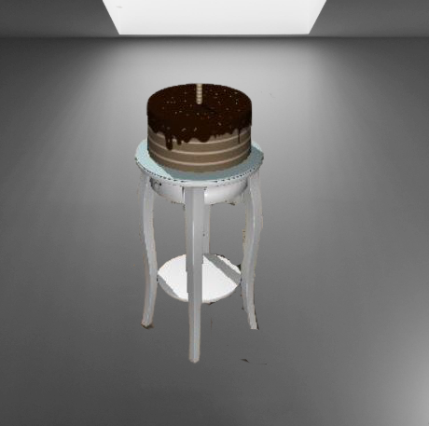
Figure 4.1 There is cake on the table

In the figure 4.1 shown above there is an scene representation with a cake above the table which is result of "There is cake on the table". The scene is represented using two objects which were identified by the object identification model and were chosen from the model dataset accordingly. The cake is positioned on the table as given in the input sentence because of the spatial relationship identified between them. In this example, the relationship was developed with the help of preposition 'on'.

Limitations
While executing this project there are many areas that needed to be looked at in a detailed manner. Different techniques were used so that the execution was done in a proper way. But still, there were many objections that gave rise in the text to scene generation while the framework shows commitment. We did address the difficulties of resolving objects, placing location, uncountable nouns. But we didn't test its wide range. We introduce different techniques in the single framework and comparing the result of each technique. But we did not introduce in which method the result of each technique will be compared. On the other hand, we used spatial knowledge to extract location semantic parsing to extract template, object, and constraints. Rule-based model to deal with an uncountable noun of objects. Therefore, a failure case may arise using this framework. So, before this, there are certain things to be taken into account like, the objects in a single sentence are in the form of supporter-dependent pairs and linked using a preposition. Each sentence has to be formed using the listed objects and prepositions. Each sentence should consist of a maximum of one supporter and two dependents only. As the complexity of the scene increases, the chances of collision rise.
Our models synthesize images based on enriched multi-captions and provide more information to the generator, which alleviates the problem of limited information. The experiments show that it can improve the quality of generated images. Moreover, our model supports incrementally generating, increasing N test, by some interactive operations as the Neural Painter. However, images synthesized from multi-captions are not a trivial task. It needs more sophisticated methods in natural language understanding and image synthesis to improve the performance further, such as semantic sentence embedding.

Conclusion
The first work in 3D scene generation relies on purely rule-based methods to map object references to concrete 3D objects. Having to introduce datasets of 3D scenes annotated with natural language descriptions which we believe will be of great interest to the research community. Using this corpus of scenes and descriptions, we present an approach that learns from data how to ground textual descriptions to objects to evaluate how our grounding approach impacts generated scene quality we will collect human judgments of generated scenes. In addition, we have presented a metric for automatically comparing generated scene templates to scenes, and we show that it correlates strongly with human judgments. We have demonstrated that rich lexical grounding can be studied directly from an unaligned corpus of 3D scenes and natural language descriptions and that our model can successfully ground lexical terms to concrete referents in improving scene generation over baselines adapted from prior work.
To choose these objects, our current system uses information obtained from language object co-occurrences and sparse manually annotated category labels another promising avenue for achieving better lexical grounding is to propagate through category labels using geometric and image features to learn the categories of unlabeled objects. These new labels could be used to improve the annotations in our 3D model database which can enable a wider range of object types to be used in scene generation

References
- Angel X. Chang, Manolis Savva, and Christopher D. Manning. 2014. Learning spatial knowledge for text to 3D scene generation. In Proceedings of Empirical Methods in Natural Language Processing (EMNLP).
- Sneha N Dessai, Prof. Rachel Dhanaraj Department of Computer Engineering GEC, Farmagudi, Ponda, Goa, India. International Journal of latest trends in Engineering and Technology(IJLTET). Vol 6 Issue 3 January 2016.
- Jun Cheng, Fuxiang Wu, Yanling Tian, Lei Wang, Dapeng Tao; Proceedings of the IEEE/CVF Conference on Computer Vision and Pattern Recognition (CVPR), 2020, pp. 10911-10920.
- Bob Coyne and Richard Sproat. 2001. WordsEye: an automatic text-to-scene conversion system. In Proceedings of the 28th Annual Conference on Computer Graphics and Interactive Techniques.
- Bob Coyne, Alexander Klapheke, Masoud Rouhizadeh, Richard Sproat, and Daniel Bauer. 2012. Annotation tools and knowledge representation for a text-to-scene system. Proceedings of COLING 2012: Technical Papers.
- Matthew Fisher, Daniel Ritchie, Manolis Savva, Thomas Funkhouser, and Pat Hanrahan. 2012. Example-based synthesis of 3D object arrangements. ACM Transactions on Graphics (TOG), 31(6):135.
- Christopher D. Manning, Mihai Surdeanu, John Bauer, Jenny Finkel, Steven J. Bethard, and David McClosky. 2014. The Stanford CoreNLP natural language processing toolkit. In Proceedings of the 52nd Annual Meeting of the Association for Computational Linguistics: System Demonstrations.
- Lee M Seversky and Lijun Yin.[2006]. “Real-time automatic 3D scene generation from natural language voice and text descriptions”. InProceedings of the14th annual ACM international conference on Multimedia.

